|  |  |
| --- | --- |
| **Test Name** | Record Service – Use case Test |
| **Use Case Tested:** | Record Service |
| **Test Description:** | The System will ask the user to enter the Roomid and the service like Bar Fridge, Restaurant and room service. When the room service is selected, It will display the cost of the service. |
| **Pre-Conditions:** | The Hotel Reservation System main menu is displayed to the user. |
| **Post-Conditions** | **Normal Flow**   * Service Charges is added to the booking and displayed in the checkout invoice.   **Unsuccessful scenarios**   * Room Id is not found. |
| **Notes:** | The flow of the Record Service is correct |
| **Results (Pass / Fail/Warning/ Incomplete)** | Pass |

|  |  |  |  |  |
| --- | --- | --- | --- | --- |
|  | **TEST STEP** | **EXPECTED TEST RESULT** | **P** | **F** |
| 1 | Prompt the user to enter the room number | Enter the Room number | **✓** |  |
| 2 | Enter the Room number | Find the booking | **✓** |  |
| 3 | Find the booking | Prompt for chose the service type | **✓** |  |
| 4 | Prompt for chose the service type | Enter the service Type | **✓** |  |
| 5 | Enter the service Type | Prompt the user to enter the Cost | **✓** |  |
| 6 | Prompt the user to enter the Cost | Enter the cost | **✓** |  |
| 7 | Cost is entered | Display the cost confirmation | **✓** |  |
| 8. | Display the cost confirmation | Enter continue | **✓** |  |

**Test Data Table**

|  |  |  |  |  |
| --- | --- | --- | --- | --- |
| Variables | Room type/room number | ServiceType | Cost | Continue |
| 1. | Single / 101 | B | $200 | Press Enter |

**Screenshot**

**The Hotel Management System main menu is displayed**

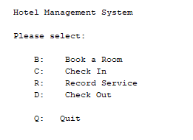

**Select B to Book a room**

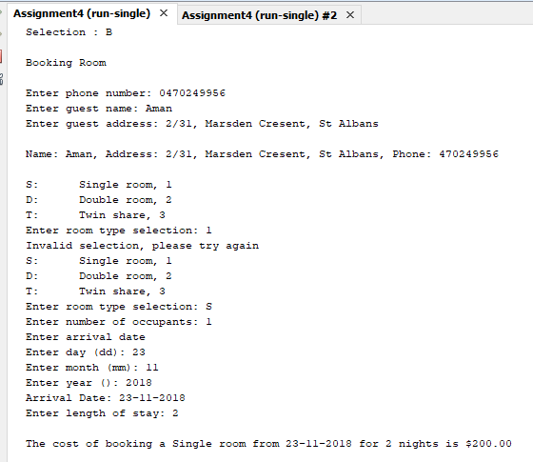

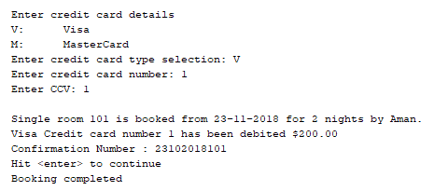

**Check in**

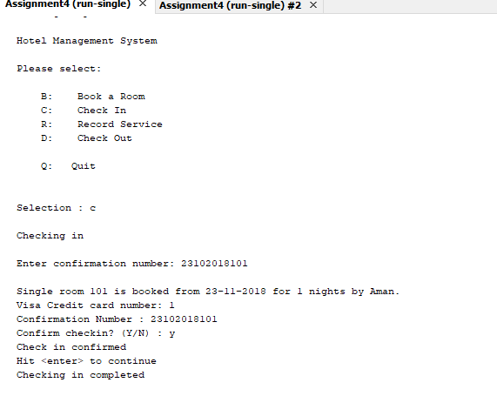

**Services**

